# General Camera Instructions

## Setting up the camera

1. Set up the tripod at a reasonable height to image the patient. Make sure that the bubble on the level is in the center.
2. Set camera up on tripod by attaching it to the base plate using the screw to secure it so it does not move.
3. Turn on and log into laptop
4. Plug one end of the USB into the laptop and the other end into the camera
5. Open the **IR Flash** software on the laptop

*You should be able to see a live image showing up

Note: Once IR Flash is open DO NOT unplug the camera until you close the software!

1. Make sure the Palette is set **Gray Scale**
2. Make sure the **AGC box us unselected**
3. Adjust the **Min** and **Max** values based on the histogram to have the best contrast

*Generally, min around 23 and max around 38

1. Focus the camera by turning the lens until the live image comes into focus

* Note that the lens is kind of hard to turn. Just be careful not to touch the lens. If you are having a hard time focusing it with the lens try moving the plate.

Note: If the live image ever starts to randomly get dark or have a weird gradient, go to **Camera** 🡪 **Image Touchup**. This would likely happen while the camera is warming up. Give the camera at least 15 minutes to warm up.

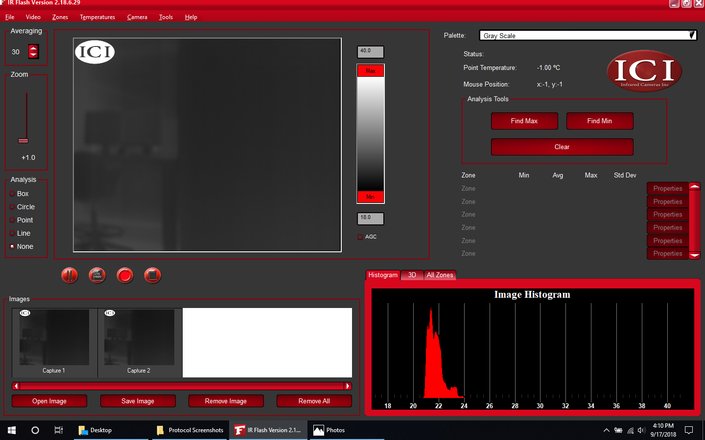

## E:\Protocol Screenshots\image series.pngTaking an Image Series

## Select **Video** 🡪 **Configure Series Image Capture**

1. Set **Capture Type** to “**Capture for fixed time**”
2. Set **Time** to **0 hours 15 minutes 0 seconds**.
3. Change **Capture Rate** to **2 Per Minute**. Select OK

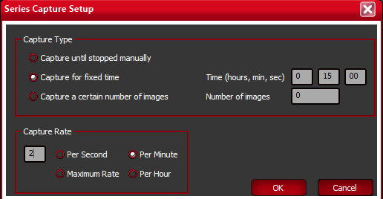

1. Select **Video** 🡪 **Capture Image Series**. Under the live image

feed you should now see a red record button.

1. To begin the image series click the **red record** button:
2. To save all the images from the series, select

File 🡪 Save All and make sure to save as a Raw 16 Bits

TIF File (*Note:* This will save all the images that are shown in the Image bar with numbers starting from NAME-0001 regardless of the capture number).

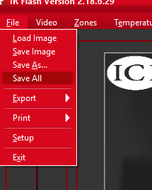

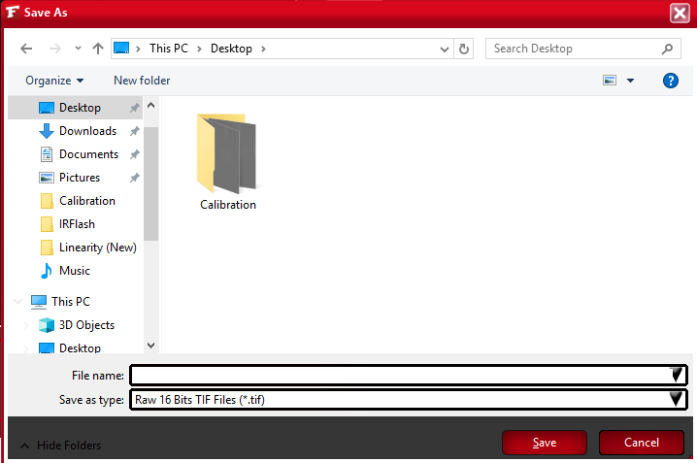

## Taking a Single Image

1. Select **Video** 🡪 **Capture Single Images**
2. To take an image click the **camera button**. It will be added to the Image bar shown below.

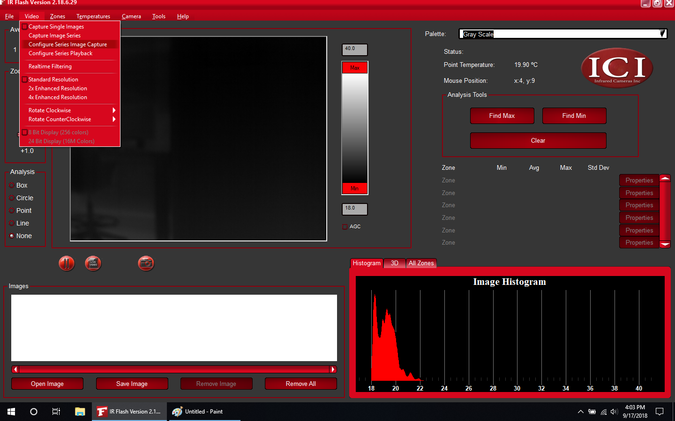

1. To save the image, select the image and click **Save Image**

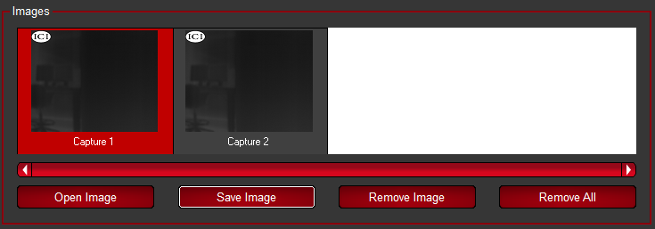

## 

# Before Patient Arrives

## Set up Camera

## Set up the camera on the tripod and plug it into the laptop. Remove the lens cap.

1. Open up the IR Flash Software and set up the camera as described above
2. Let the camera warm up while setting up. The camera should be allowed at least 15 minutes to warm up.
3. Go ahead and configure the image series as described above.

## Chair Setup and Focusing

1. Set up chair and arm supports. Have the two arm supports be at the same height.
2. Have someone sit in the chair for the initial setup.

*This will need to be adjusted when the patient arrives

1. Point the camera directly at the chair and adjust the focus on the camera

**\* Make sure the platform is about halfway back. This will be important for focusing the camera on the side mirrors**

**\* Turn the lens until the image is in focus**

* Careful not to unscrew or touch the lens

* Have the patient hold an object like a watch or headphones to better focus

1. Turn the camera using the handles on the tripod to point at one of the side mirrors. Mark the position that you turn the camera so it is easy to return to later

* Do not turn the plate because it will likely come off the tripod. Instead turn the handles

1. Position the side mirror on the pole of the arm support so as much of the side of the breast is visible as possible. Once the mirror is in place, use the red knob on the flex bars to lock them in place.
2. If necessary, adjust the focus so the breast on the mirror is in focus

* Make sure to focus on the mirror and not the patient

* Adjust the focus my moving the platform (not the lens). Use a Post-it to note the position of the platform.

1. Do the same for the other side mirror

# After Patient Arrives

1. Welcome the patient and thank her for her time.
2. Explain the procedure including key points:

* Imaging will take 15 minutes after she undresses

* She needs to stay as still as possible for the entire time

## Adjust Chair Setup and Camera for Patient

1. With her clothes on, adjust the height of the arm rests to make the patient comfortable.
2. Also adjust the height and position of the camera to get as much of her chest as possible
3. Adjust the position of the mirrors, so that it shows the full side of the breast. Make sure the mirrors are not in contact with the patient. (See attached images for reference)
4. 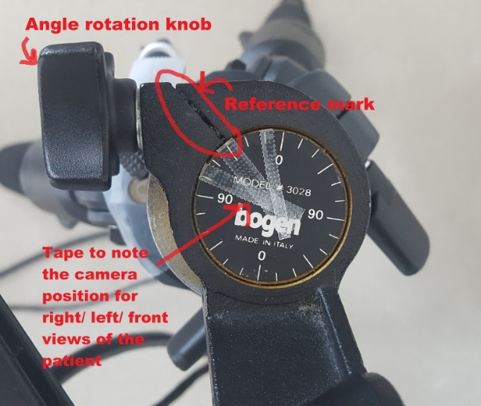Rotate the camera and have it face the right side mirror (make sure the level bubble is still centered).   
   Once a good position is set to show a full and focused view of the breast side, **note the angle with the reference line with a thin piece of tape** (As shown in the image)
5. Repeat for the left side mirror, and note its angle against the reference line with another piece of tape.
6. Ask the patient to hold a watch or bracelet as close as possible to her nipple or chest
7. Then **focus** the camera as best as possible on the edges of the watch,   
   **Do not touch the lens.**
8. Put a reference mark with a thin piece of tape on the outer non-moving ring of the lens. Then, put another thin piece of tape on the moving focusing ring to mark where you found the best focus and have it align with the reference tape.
9. Rotate the camera on the left side where you marked the position with tape.
10. Have the patient hold a watch or bracelet next to the side of their breast.
11. Focus the camera on the breast reflection on the mirror (not on the patient!), use the watch to help find a good focus.
12. Mark the new focus location with a piece of tape on the moving focus ring of the camera and have it align with the reference tape.
13. Repeat for the other mirror
14. Measure the distance between the patient and the camera with the measuring tape, and write it down in the lab notebook.

Image Ruler and Final Check

1. Ask the patient to hold a ruler from the middle point (provided in the black bin) **horizontally** as close to her chest as she can, and at approximate nipple height.
2. Make sure the sides of the ruler are shown clearly in the image and are not obscured by the background (See sample image below)
3. Take **single image** of the patient holding the ruler.

* Save the image with the patient ID, for example, *IRST012_ruler*

1. **Before asking the patient to undress**, double check the following:

* The mirrors are still in good position
* The focus reference marks are labeled
* The rotation angles for the camera are labelled
* The setup on IR Flash for taking the image series is prepared (this is to save time of cooling after the patient undresses)
* Ask if the patient is wearing a high-waist pants/skirt or if she’s wearing nipple piercings. Kindly ask the patient if she can push down her pants/skirt below her navel when she undresses later, and if she can remove her piercings.

Imaging Patient

1. **Ask the patient to remove her upper clothing**, and do the following as quickly as possible:
2. Let her sit back on the chair and position her arms on the already-adjusted supports so that they are away from the sides of her breasts. Ask the subject to remain as still as possible.
3. As quickly as possible, readjust the tripod/mirrors if necessary
4. Readjust the focus to the reference mark of the mirror and take **one image** of the **right side mirror**, using the tape mark you set as a reference. This should be saved in the image bar as Capture 1 (see below).



1. Take one image of the left side mirror. This is Capture 2.
2. Put the camera pack to the frontal view and adjust the focus based on the reference mark made in part E. Select **Video 🡪 Capture Image Series** and then, i**mmediately begin imaging** for 15 minutes

* Feel free to talk with the subject if she wishes, as long as she doesn’t move.

* These images should be titled Capture 3-32 and beyond in the Images bar.

1. Once the 15 minutes are over, take two more images of the side mirrors (right then left). These will be Capture 33 and Capture 34.
2. Tell the subject that “we are finished”, ask her to re-dress, and **thank her for her participation.**

# Saving the Images

1. In Documents, create a folder with the Patient ID *ex. IRST014*
2. Select Capture 1 and Save Image as: *IRSTXXX_Right_min0*
3. Select Capture 2 and Save Image as *IRSTXXX_Left_min0*
4. **Remove Capture 1 and 2** by selecting the images and then clicking Remove Image



1. Select the last two images, Capture X and Capture Y and save them as *IRSTXXX_Right_min15* and *IRSTXXX_Left_min0* respectively
2. **Remove Capture 33 and 34 as well**
3. Select File 🡪 Save All and save the images from the series. Set the file name as the patient ID (*IRSTXXX)*

# Example Images

